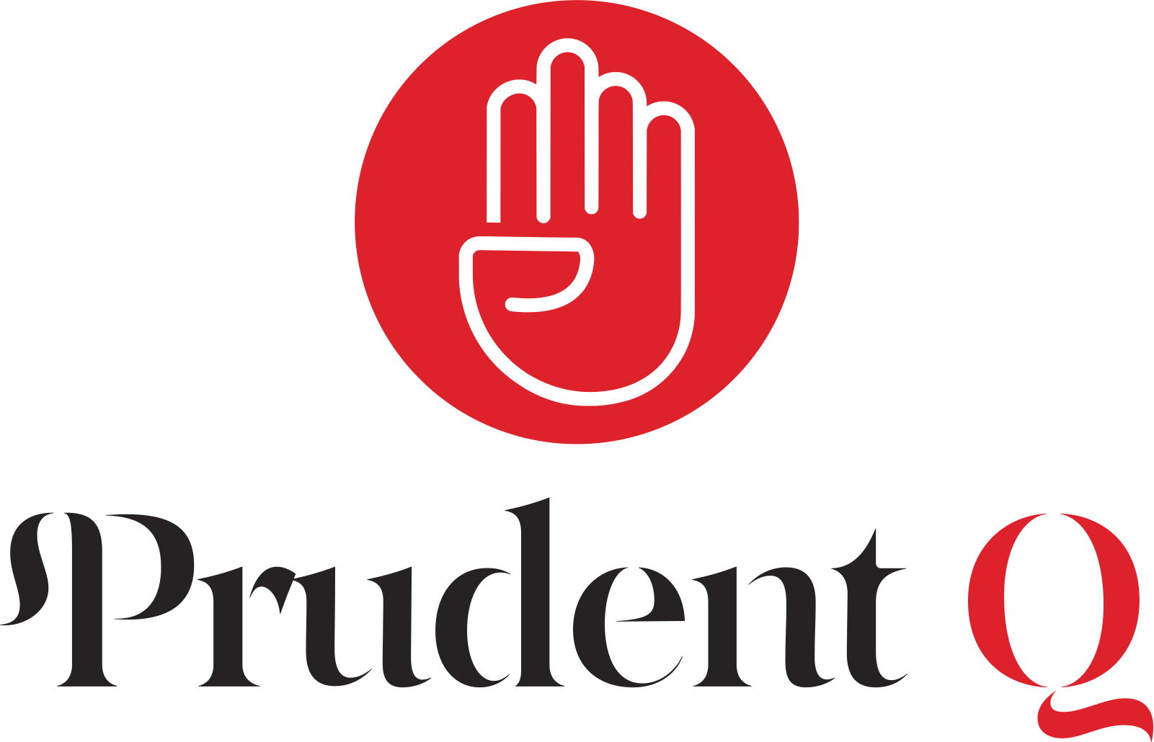

Resume
Business, Legal, Compliance & Risk Management Consulting Firm
📍 3014 Dauphine St. Ste. A, PMB 901672 New Orleans, Louisiana 70117 | LLC | Manager-Managed
📧 prudentqfirm@gmail.com | 📞 504-390-0823 | 🌐

Summary
Bold, trustworthy, and detail-oriented consulting firm specializing in business advisory, legal & regulatory compliance, and enterprise risk management. Partner to organizations across industries including healthcare, financial services, government, and technology. Known for integrating compliance and risk strategies into daily operations to safeguard continuity and reputation while driving sustainable growth.

Core Competencies
• Business Advisory - business formation, strategic planning, operational efficiency
• Compliance – regulatory audits, licensing, ESG/CSR compliance
• Risk Management - crisis response and prevention, cybersecurity, insurance strategy
• Legal Support (non-attorney) - contracts, governance, Policies

Key Achievements
• Developed compliance and risk frameworks for financial, healthcare, and government contractors.
• Delivered scalable solutions for startups, SMEs, and large enterprises, reducing compliance costs.
• Positioned as a trusted advisor embedding compliance into growth models.
• Leveraged advanced technology for real-time compliance monitoring and risk analytics.

Service Offerings
Business Advisory | Legal Consulting (Non-Attorney) | Compliance Services | Risk Management | Education

Target Markets
Financial Services | Healthcare & Life Sciences | Government Contractors | Technology Companies | SMEs & Startups

Competitive Advantages
• Holistic Approach – integrates business strategy, compliance, and risk
• Technology-Forward – AI-driven analytics and compliance software
• Scalable Solutions – customizable for startups through enterprises
• Trusted Partnerships – works alongside legal counsel, accountants, and risk advisors
• Client-Centric – relationship-driven, transparent, measurable outcomes

